**Meter disconnect/reconnect package**

When testing any vendor role, the EC2 instance will take on the roles of the other two vendors. For example, when testing CIS, the EC2 instance will take on roles of MDMS, AMI headend.

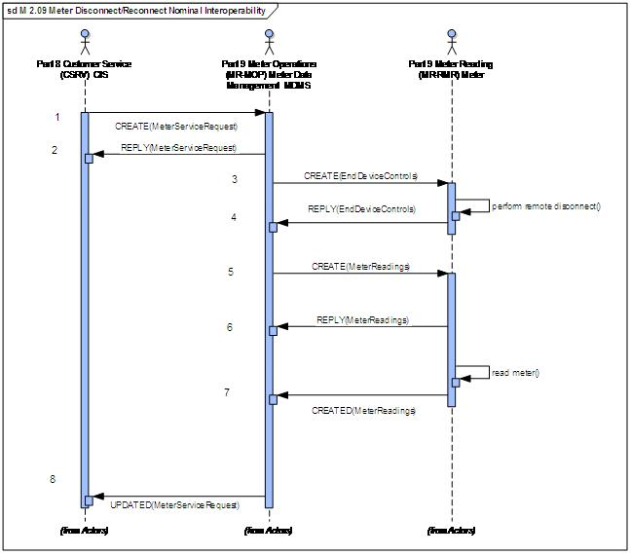

All messages should have the ability to be proxied.

I think we want separate endpoints for each item below, so that we can track separately in the database. For the hooks, where we send back well formatted messages, we don't really need to log, as we can't do any validation, other than we sent a message. I think we should log anyway, that we successfully delivered the message.

For each of these, I think we need a separate interface tag - for CIS, I suggest

CIS - Create1 for line item #1

CIS - Reply1, for line item #2

**CIS**

1. Verify that CREATE(#1 MeterServiceRequest) request is correct

EC2 instance receives, parses

2. Provide hook to send meter service request

EC2 provides service to send REPLY(#2 MeterServiceRequest)

**MDMS**

1. Provide hook to generate meter service request

EC2 provides service to send CREATE(#1 MeterServiceRequest)

2. Verify that REPLY(#2 MeterServiceRequest) is correct

EC2 instance receives, parses

3. Verify that CREATE(#3 EndDeviceControls) is correct

EC2 instance receives, parses

4. Provide hook to generate reply

EC2 provides service to send REPLY(#4 EndDeviceControls)

5. Verify that CREATE(#5 MeterReadings) is correct

EC2 instance receives, parses

6. Provide hook to generate reply

EC2 provides service to send REPLY(#6 MeterReadings)

7. Provide hook to generate meter readings

EC2 provides service to send CREATED(#7 MeterReadings)

8. Verify that UPDATED(#8 MeterServiceRequest) is correct

EC2 instance receives, parses

**AMI**

1. Provide hook to generate create request(end device control)

EC2 provides service to send CREATE(#3 EndDeviceControls)

2. Verify that REPLY(#4 EndDeviceControls) is correct

EC2 instance receives, parses

3. Provide hook to generate create request(meter readings)

EC2 provides service to send CREATE(#5 MeterReadings)

4. Verify that REPLY(#6 MeterReadings) is correct

EC2 instance receives, parses

5. Verify that CREATED(#7 MeterReadings) is correct

EC2 instance receives, parses